----------------------------------------------------------------------

Eric 1 May 2017

Brainstorming on the kinematics

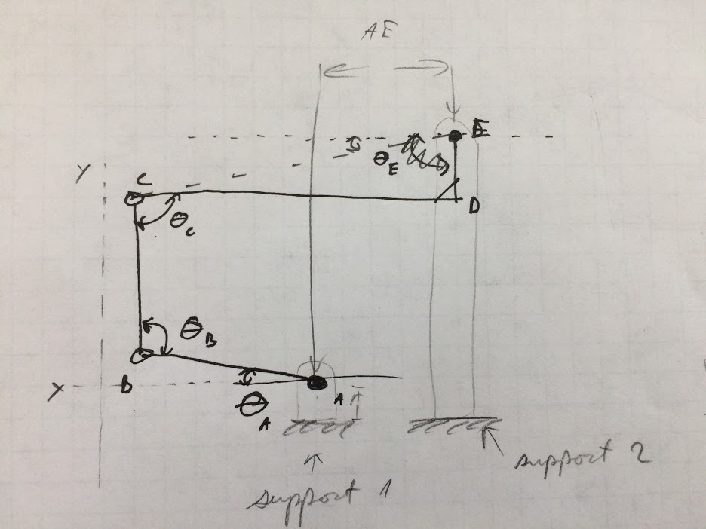

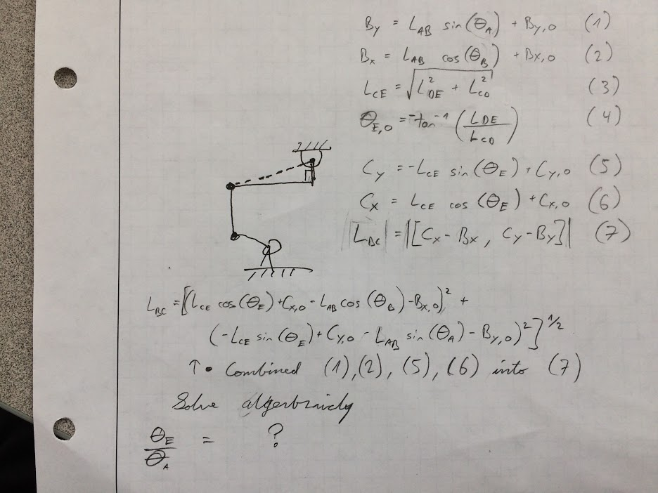

----------------------------------------------------------------------

Eric 26 Apr 2017

I’ve created a crude solidworks model as a tool for motion study. The linkage dimensions are arbitrary and can be updated when we get them. I was able to run a motion simulation and get angular displacement v. time of the driving link and the platform. These can be outputted to .csv for further analysis to extract a transfer function.

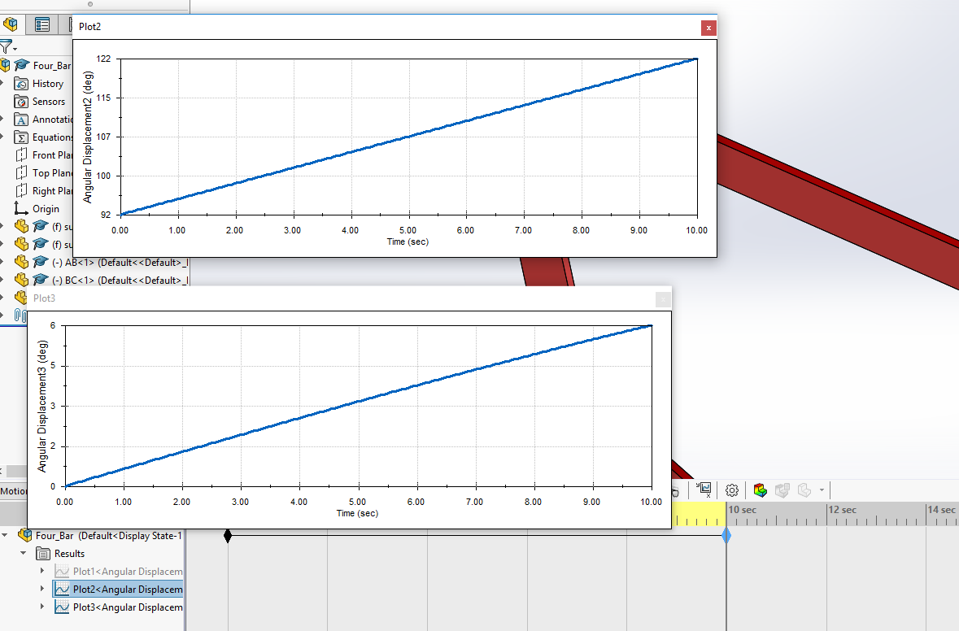

It’s in this folder as in a pack-and-go zip file (four_bar.zip) if anyone wants to take it for a spin or modify it.

---------------------------------------------------------------------------------------------------